Ansible Tasks-01
- Watch ansible-01 video and write down notes.
- Setup one master and two worker nodes in ansible.
- Execute the adhoc command shared in #dvps-cloud-documents-12 Channel

Ansible-01: Setup and Ad-hoc Commands
1. Introduction to Ansible
Ansible is an open-source automation and configuration management tool used to manage servers, configure systems, deploy applications, and automate repetitive IT tasks.
Ansible is developed in Python and uses SSH to communicate with Linux managed nodes in a typical Linux environment.
Key Features
- Agentless: No Ansible agent is normally required on managed Linux nodes.
- Push-based: The control node sends tasks to managed nodes.
- Simple and readable: Uses YAML for playbooks.
- Idempotent: Many Ansible modules can be run repeatedly while maintaining the desired state.
- Configuration management: Helps maintain consistent configurations across multiple servers.
- Automation: Can automate software installation, service management, file operations, and deployments.
2. Ansible Architecture
An Ansible environment consists of the following components:
Control Node
The machine where Ansible is installed and from which commands and playbooks are executed.
Managed Nodes
The remote servers managed by Ansible. These are also commonly called hosts or worker nodes.
Inventory
A file that lists the managed hosts, IP addresses, groups, and optional connection variables.
Modules
Reusable units of code that perform specific operations, such as checking connectivity, managing files, installing packages, and controlling services.
Ad-hoc Commands
One-time commands executed from the control node to perform quick administrative tasks.
Playbooks
YAML files containing one or more tasks that automate a sequence of operations.
Communication
For Linux hosts, Ansible typically uses SSH to connect to managed nodes. SSH key-based authentication is commonly used.
3. Ansible Inventory
An inventory defines which machines Ansible manages.
Two inventory approaches covered in the training are:
- Static inventory: Hosts are listed manually in a file.
- Dynamic inventory: Hosts are discovered from an external source, such as a cloud provider.
Example static inventory:
[workers]
192.168.0.1
192.168.0.2
192.168.0.3
The default inventory is commonly located at /etc/ansible/hosts. A custom inventory file can also be specified using the -i option.
4. Ansible Ad-hoc Command Syntax
General syntax:
ansible <host-pattern> -m <module> -a "<arguments>"
Important options:
- ansible: Runs the Ansible command-line tool.
- all: Targets all hosts in the selected inventory.
- -m: Specifies the module to execute.
- -a: Supplies arguments to the module.
- -i: Specifies an inventory file.
- -u or --user: Specifies the remote SSH user.
- -b: Enables privilege escalation (become).
- -K: Prompts for the become password.
- --ask-pass: Prompts for the SSH password.
5. Common Ad-hoc Commands
A. Check connectivity
ansible all -m ping
Uses the Ansible ping module to verify that managed nodes are reachable and able to execute Ansible modules.
Using a custom inventory:
ansible all -m ping -i ansible_hosts
B. Gather system facts
ansible all -m setup
Collects system information from managed hosts, including operating system details, IP addresses, memory, processor information, and other available facts.
C. Connect using SSH password authentication
ansible all -m ping --user=ansadm --ask-pass
Uses the specified remote user and prompts for the SSH password. The SSH server must permit the required authentication method.
D. Check system uptime
ansible all -a "uptime"
Displays how long the managed system has been running and provides load-average information.
E. Check memory usage
ansible all -a "free -m"
Displays memory and swap information in megabytes.
F. Execute a command with privilege escalation
ansible all -m shell -a "cat /etc/passwd | grep -i ansadm" -b -K
Runs the shell command with privilege escalation and prompts for the become password.
The command searches /etc/passwd for entries matching ansadm, ignoring case.
G. Create a directory as a different user
ansible all -m file -a "path=/home/ansadm/test state=directory mode=0755" -b --become-user=ansadm
Creates the directory /home/ansadm/test with permissions 0755, using privilege escalation to act as ansadm.
H. Create a Linux group
ansible all -m group -a "name=test state=present" -b -K
Ensures that a group named test exists on the managed nodes.
I. Create a file with permissions 755
ansible all -m file -a "path=/home/ansadm/testfile state=touch mode=0755"
Creates the file if it does not exist and sets its permissions to 0755. The target directory must exist, and the remote user must have the required permissions.
J. Change file ownership
ansible all -m file -a "path=/home/ansadm group=weblogic owner=weblogic" -b
Changes the ownership of the specified path to user weblogic and group weblogic. Those accounts must exist on the managed hosts.
K. Install Apache using the yum module
ansible all -m yum -a "name=httpd state=installed"
Ensures that the Apache HTTP server package is installed on compatible Red Hat-based systems.
L. Start and enable Apache
ansible all -m service -a "name=httpd state=started enabled=yes"
Starts the Apache service and enables it to start automatically during system boot.
M. Stop Apache
ansible all -m service -a "name=httpd state=stopped"
Stops the Apache service.
Note: The package manager and service names depend on the operating system. Ubuntu systems generally use the apt module for package installation.
6. Ansible Ad-hoc Commands vs. Playbooks
Ad-hoc commands | Playbooks
Used for quick, one-time tasks | Used for structured automation
Executed directly from the command line | Written in YAML
Usually suited to individual operations | Can contain multiple tasks and roles
Useful for troubleshooting and administration | Useful for repeatable deployments and configuration
7. Other Configuration Management Tools
The training also mentions these tools:
- Chef: A configuration management tool that uses a pull-based approach in common client-server deployments.
- Puppet: A configuration management tool that commonly uses an agent-based pull model.
- SaltStack: An automation and configuration management platform that supports multiple execution models.
8. Important Key Points
- Ansible is an open-source configuration management and automation tool.
- The control node executes commands against managed nodes.
- Linux managed nodes commonly use SSH for communication.
- Inventory files define the hosts Ansible manages.
- Static inventory lists hosts manually; dynamic inventory discovers hosts from external sources.
- Ad-hoc commands are useful for quick administrative tasks.
- The ping module tests Ansible connectivity, not ordinary ICMP ping.
- The setup module gathers system facts.
- The file, group, yum, and service modules manage system resources.
- The -b option enables privilege escalation, and -K prompts for the become password.
- Playbooks are written in YAML and are suitable for repeatable, multi-step automation.
- Always verify the target hosts and inventory before running commands that modify systems.
9. Conclusion
Ansible simplifies server administration by automating repetitive tasks across multiple machines. Understanding its architecture, inventory, SSH connectivity, modules, ad-hoc commands, and playbooks provides a foundation for managing Linux servers and building automation workflows.

Task 2 — Ansible Master and Two Workers
Architecture
Ansible Master
Ubuntu • Ansible installed • SSH client
ansible-master
SSH using a dedicated lab user
Worker 1
ansible-worker1
Managed node
Worker 2
ansible-worker2
Managed node
Phase 1 — Create three EC2 instances
Step 1. Open EC2
- Open the AWS EC2 Console.
- Select Asia Pacific (Hyderabad) — ap-south-2.
- Click Instances → Launch instances.
Step 2. Configure the Master
Use these settings:
Setting | Value
Name | ansible-master
AMI | Ubuntu Server 24.04 LTS
Architecture | 64-bit x86
Instance type | t3.micro, if available and suitable
Storage | 8 GiB
Key pair | Create ansible-lab-key
VPC | Default VPC is suitable for this basic lab
Public IP | Enable, if you need to connect directly over SSH
Create and download the .pem key file. Store it securely; AWS will not let you download the same private key again later.
Click Launch instance.
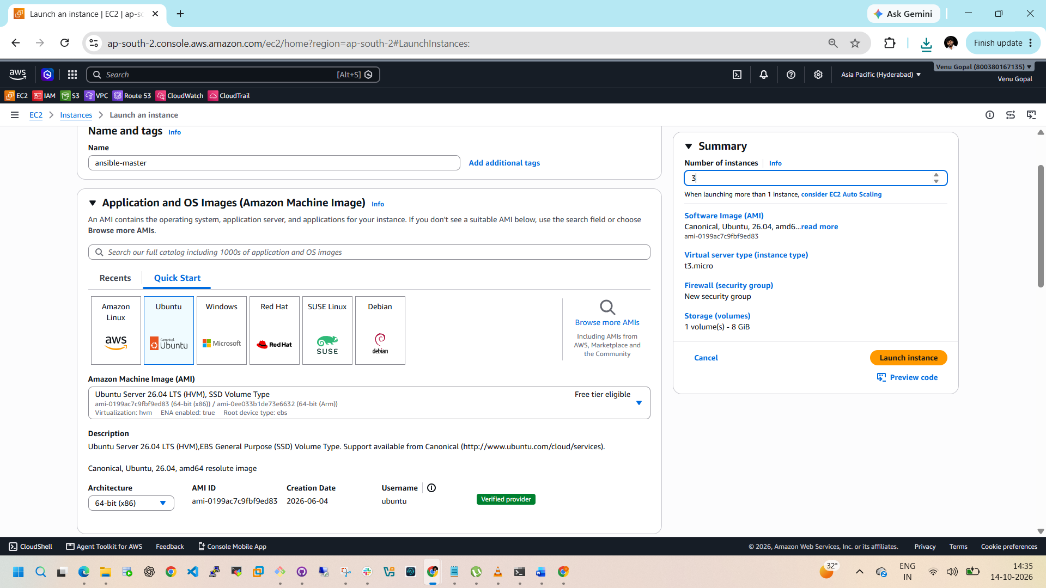
Step 3. Configure Worker 1 and Worker 2
Repeat the launch process twice with the same operating system, instance type, VPC, and key pair.
Use these names:
- ansible-worker1
- ansible-worker2
For this lab, use the same key pair for all three instances. Keep them in the same VPC and preferably the same subnet.
Cost reminder: Three instances and their storage or public IPv4 addresses may incur charges. Check your current pricing and Free Tier eligibility before launching. Stop or terminate resources when you finish, depending on whether you need to retain them.
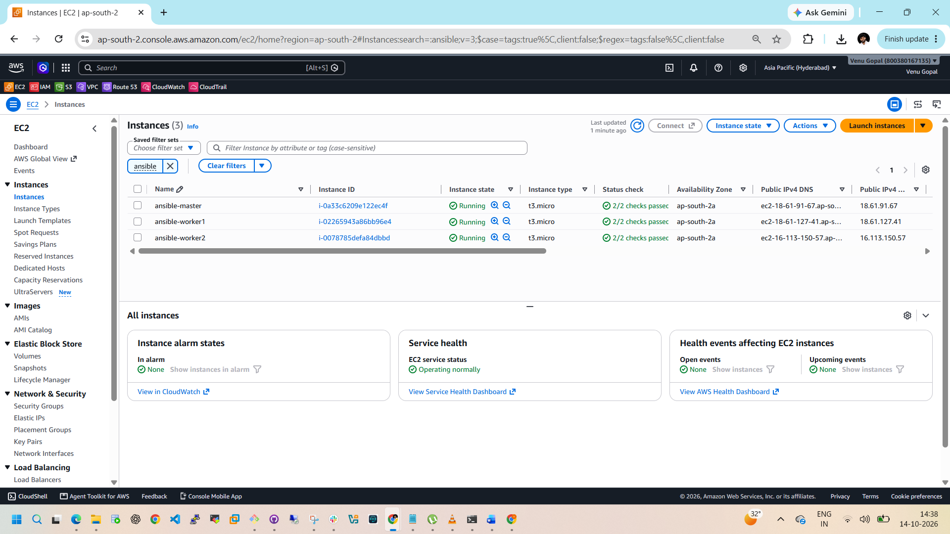
Phase 2 — Configure networking
Step 4. Configure security groups
For the initial setup, allow SSH access on TCP port 22 from My IP for your own workstation.
Then configure a security group rule for the workers that permits TCP port 22 from the Master’s security group. This is preferable to opening SSH to the entire internet.
Ensure the instances can reach Ubuntu package repositories, either through public internet access or an appropriate NAT/network setup.
Step 5. Record private IP addresses
Open EC2 → Instances and record the private IPv4 addresses.
Example only — replace these with your actual addresses:
Instance | Example private IP
Master | 10.0.1.10
Worker 1 | 10.0.1.11
Worker 2 | 10.0.1.12
Do not copy these example IPs into your inventory unless they match your instances.
Phase 3 — Connect to the Master
Step 6. Connect from Windows
If you use Windows PowerShell and downloaded your key to Downloads, run:
ssh -i "$HOME\Downloads\ansible-lab-key.pem" ubuntu@MASTER_PUBLIC_IP
Replace MASTER_PUBLIC_IP with the Master’s public IPv4 address.
If SSH says the key permissions are too open, correct the Windows file permissions before trying again.
Alternatively, select the Master in EC2 and click Connect → EC2 Instance Connect, if supported and configured.
Step 7. Update the Master
After you connect, execute:
sudo apt update
sudo apt upgrade -y
Install Ansible and SSH utilities:
sudo apt install -y ansible openssh-client
Verify the installation:
ansible --version
ssh -V
Expected: Ansible and SSH version details are displayed.
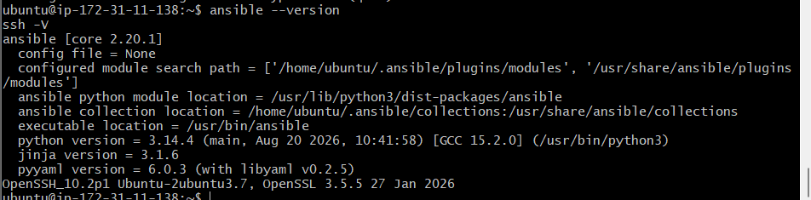
Phase 4 — Prepare the Worker Nodes
Step 8. Connect to Worker 1 and Worker 2
Use the EC2 Connect option or SSH from your workstation to each worker. Run these commands on both workers:
sudo apt update
sudo apt install -y python3 openssh-server
sudo systemctl enable --now ssh
Create a dedicated Ansible user:
sudo adduser ansadm
Set a password when prompted. Repeat the process on Worker 2, using the same username.
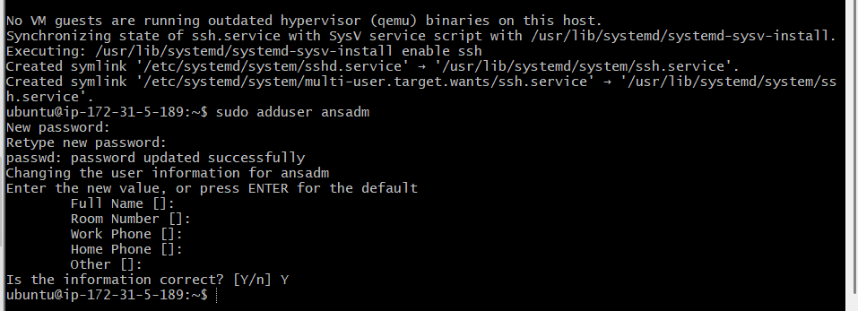
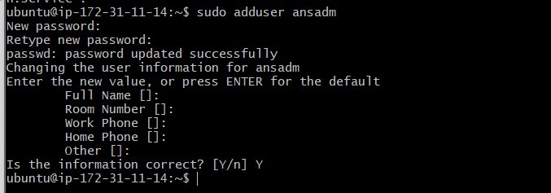

For the training’s privilege-escalation commands, configure sudo access for ansadm on both workers:
sudo visudo
Add this line at the end:
ansadm ALL=(ALL:ALL) ALL
Save and exit. This allows ansadm to use sudo with a password when authorized.
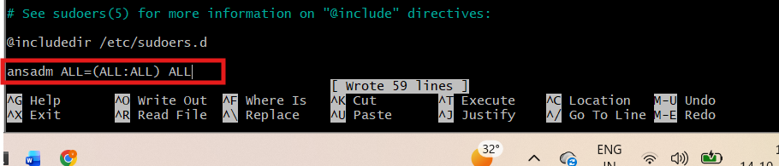
Check SSH is running:
sudo systemctl status ssh
Repeat these steps on the second worker. You do not need to install Ansible on the workers.
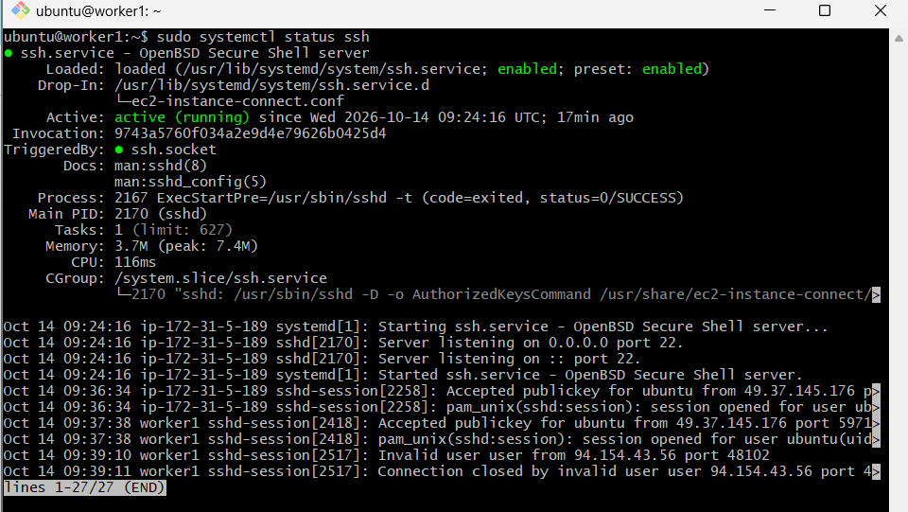
Phase 5 — Configure SSH from Master to Workers
Step 9. Generate an SSH key on the Master
Return to the Master terminal and run:
ssh-keygen -t ed25519
Press Enter to accept the default file location. For this lab, you may leave the passphrase empty so Ansible can run non-interactively.
Verify the key files:
ls -l ~/.ssh/
You should see id_ed25519 and id_ed25519.pub.
SHA256:ScsQFLVwGqqQJOIcHL65uEgYmMNNKNq6WC6BQlHAEQo
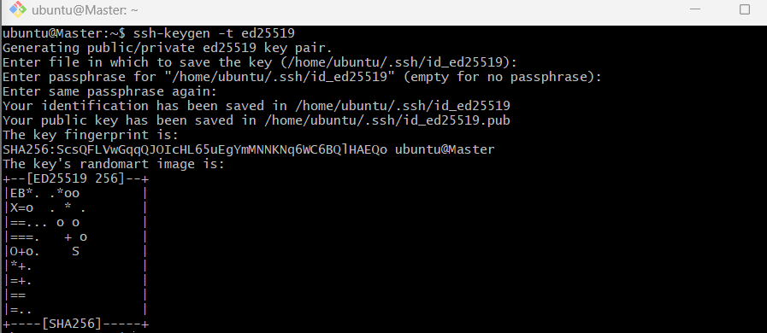

Step 10. Copy the public key to each worker
From the Master, run:
ssh-copy-id ansadm@WORKER1_PRIVATE_IP
Then:
ssh-copy-id ansadm@WORKER2_PRIVATE_IP
Enter the ansadm password for each worker when prompted.
If ssh-copy-id is unavailable, you can manually append the contents of the Master’s ~/.ssh/id_ed25519.pub to each worker’s /home/ansadm/.ssh/authorized_keys, ensuring the .ssh directory is owned by ansadm with mode 700 and authorized_keys with mode 600.
Test SSH access from the Master:
ssh ansadm@WORKER1_PRIVATE_IP
Then exit:
exit
Repeat the test for Worker 2.
Success condition: Both SSH connections work without prompting for the worker account password.
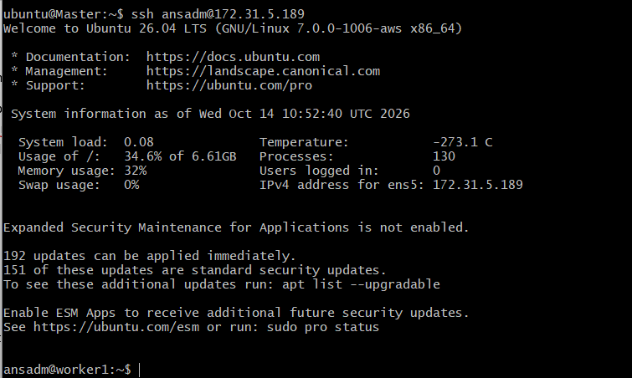
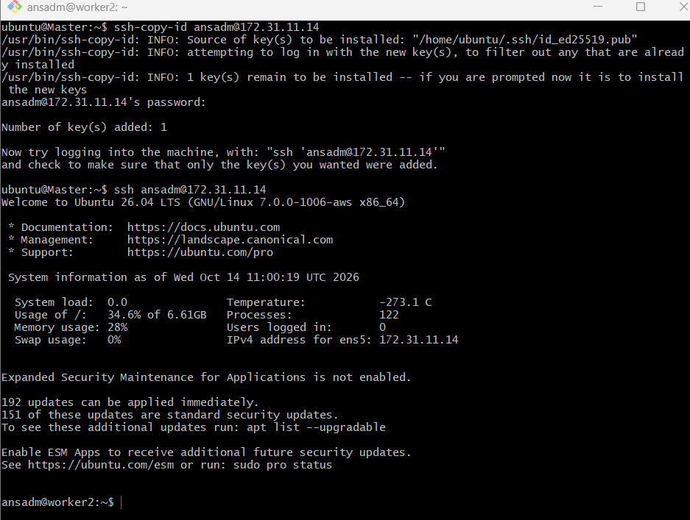
Phase 6 — Configure the Ansible inventory
Step 11. Create a project directory
On the Master:
mkdir -p ~/ansible-lab
cd ~/ansible-lab
Create the inventory:
nano ansible_hosts
Add your actual worker private IP addresses:
[workers]
worker1 ansible_host=WORKER1_PRIVATE_IP
worker2 ansible_host=WORKER2_PRIVATE_IP

[workers:vars]
ansible_user=ansadm
ansible_python_interpreter=/usr/bin/python3
Save the file with Ctrl+O, Enter, and exit with Ctrl+X.
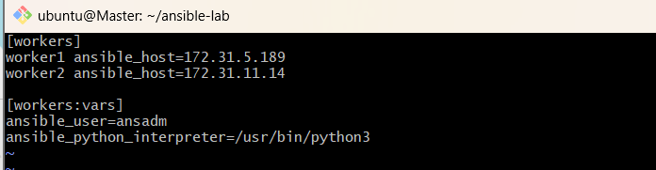
Check the inventory:
cat ansible_hosts
ansible-inventory -i ansible_hosts --list
The output should show both workers.
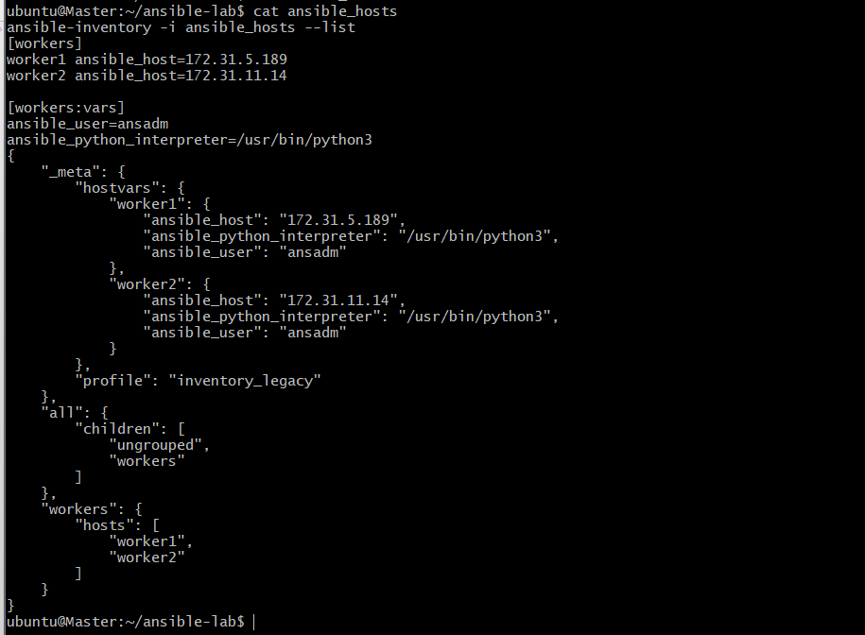
Phase 7 — Verify connectivity
Step 12. Ping both workers
Run this from ~/ansible-lab on the Master:
ansible all -m ping -i ansible_hosts
Expected output will resemble:
worker1 | SUCCESS => {
"changed": false,
"ping": "pong"
}
worker2 | SUCCESS => {
"changed": false,
"ping": "pong"
}
The private IPs, hostnames, and exact output will differ in your environment.
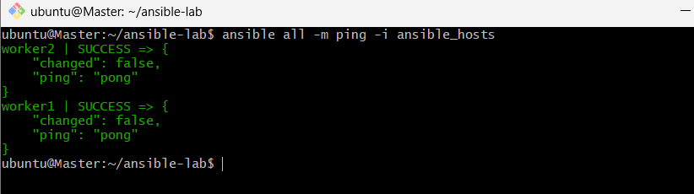
Step 13. Check the operating systems
ansible all -m setup -i ansible_hosts
This gathers system facts from both managed nodes. The output can be long.
For a shorter operating-system check:
ansible all -m setup -i ansible_hosts -a 'filter=ansible_distribution*'
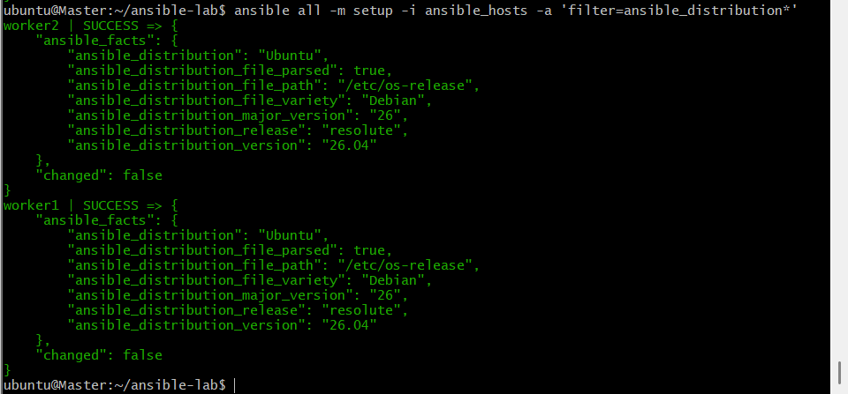
Step 14. Check uptime
ansible all -a "uptime" -i ansible_hosts
Both workers should return their uptime information.
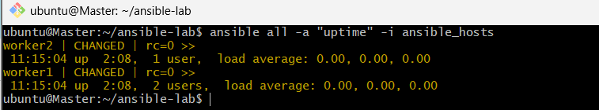

Task 3 — Ansible Ad-hoc Commands
Before starting
Run these commands on your Ansible Master terminal:
cd ~/ansible-lab
cat ansible_hosts
Confirm that the inventory contains both workers.
Step 1 — Check connectivity
Already completed
Command:
ansible all -m ping -i ansible_hosts
Expected: both worker1 and worker2 return "ping": "pong".
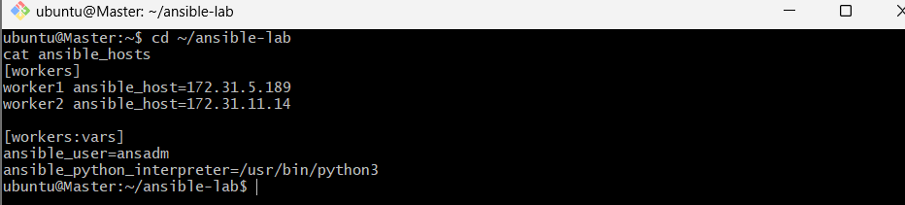
Step 2 — Gather facts from both workers
ansible all -m setup -i ansible_hosts
This displays detailed system information and produces lengthy output.
For a shorter operating-system check, run:
ansible all -m setup -a 'filter=ansible_distribution*' -i ansible_hosts
Expected: operating system distribution information for both workers.
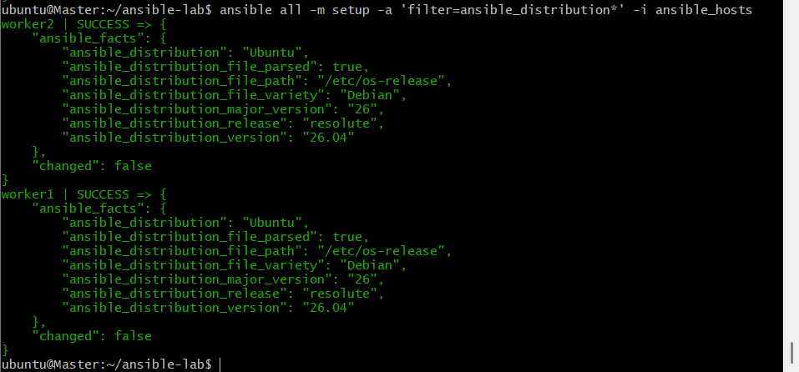
Step 3 — Test SSH password authentication
Your training sheet includes:
ansible all -m ping --user=ansadm --ask-pass -i ansible_hosts
This prompts for the SSH password. Run this only if password-based SSH authentication is enabled on the workers. If your SSH key-based authentication is already working and password authentication is disabled, skip this test.
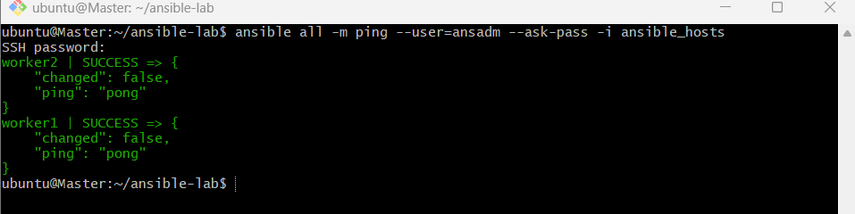
Step 4 — Check worker uptime
Already completed
ansible all -a "uptime" -i ansible_hosts
Your screenshot confirmed that both workers responded successfully.
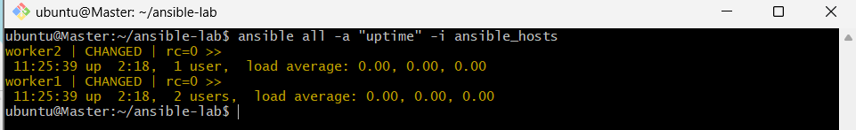
Step 5 — Check memory usage
ansible all -a "free -m" -i ansible_hosts
Expected: memory and swap statistics in megabytes for both workers.
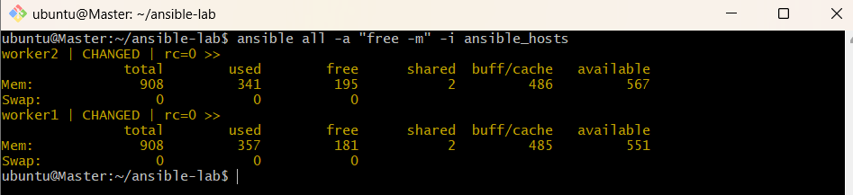
Step 6 — Execute a shell command with sudo
The original sheet uses older sudo options. Use the following command instead:
ansible all -m shell -a "cat /etc/passwd | grep -i ansadm" -b -K -i ansible_hosts
- -m shell: Executes a shell command.
- -b: Enables privilege escalation.
- -K: Prompts for the become password.
Enter the ansadm sudo password when prompted. This assumes the remote user has sudo privileges.
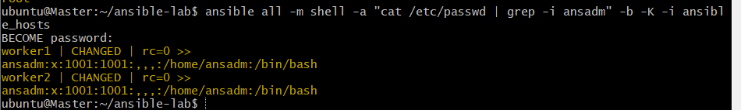
Step 7 — Create a directory as ansadm
ansible all -m file -a "path=/home/ansadm/test state=directory mode=0755" -b --become-user=ansadm -i ansible_hosts
Expected: the directory /home/ansadm/test is created on both workers.
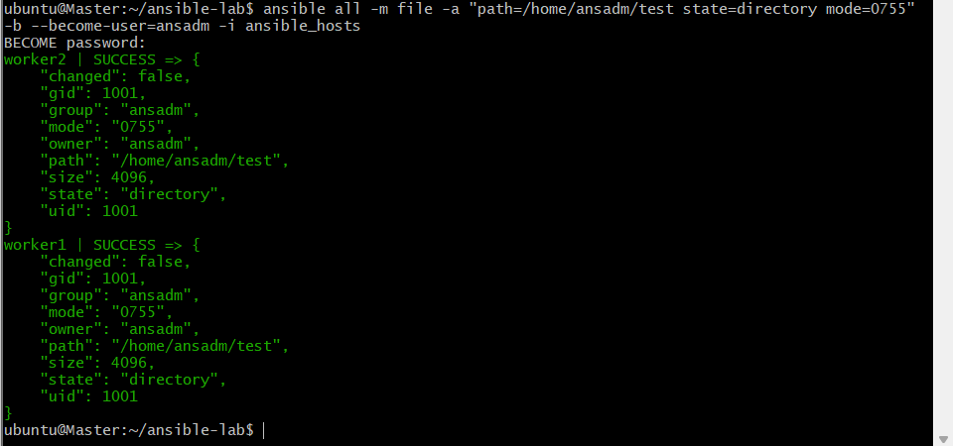
Step 8 — Create a Linux group
ansible all -m group -a "name=test state=present" -b -K -i ansible_hosts
Expected: the test group exists on both workers.
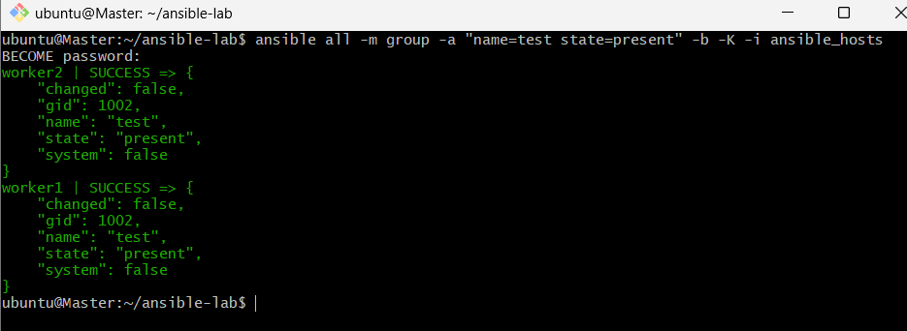
Step 9 — Create a file with 755 permissions
Your sheet contains a path typo (asnadm). Use the correct username, ansadm.
ansible all -m file -a "path=/home/ansadm/testfile state=touch mode=0755" -i ansible_hosts
Expected: the file is created on both workers with permissions 755, provided ansadm has permission to write to that directory.
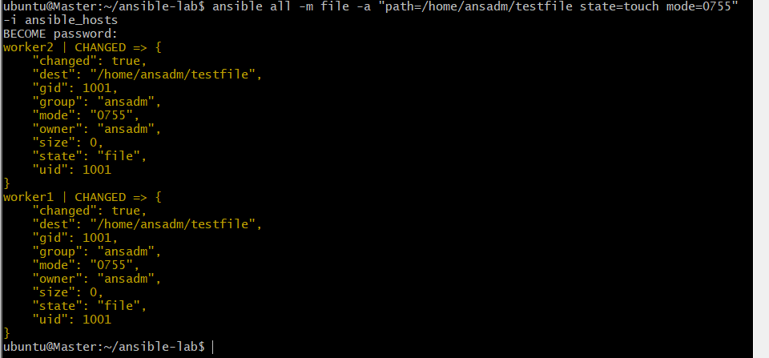
Step 10 — Change file ownership
The original command changes ownership of /home/ansadm itself. For a safer exercise, create a separate file first and change its ownership instead.
First, verify that the weblogic user and group exist:
ansible all -m shell -a "id weblogic" -i ansible_hosts
If they exist, run:
ansible all -m file -a "path=/home/ansadm/testfile owner=weblogic group=weblogic" -b -K -i ansible_hosts
If weblogic does not exist, skip this step for now rather than creating accounts unnecessarily.
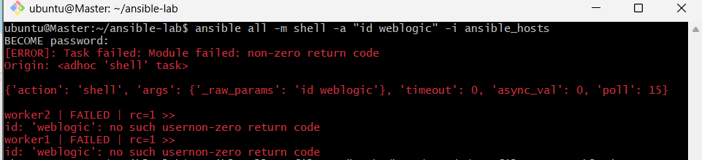
Step 11 — Install Apache
Your training sheet uses the yum module and httpd package. Because our lab uses Ubuntu, use apt and apache2 instead.
ansible all -m apt -a "name=apache2 state=present update_cache=yes" -b -K -i ansible_hosts
Expected: Apache is installed on both workers.
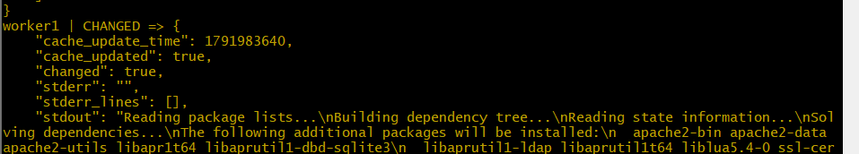
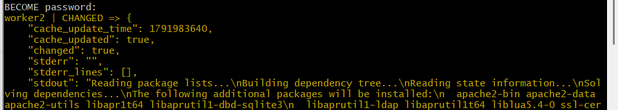
Step 12 — Start and enable Apache
ansible all -m service -a "name=apache2 state=started enabled=yes" -b -K -i ansible_hosts
Expected: Apache is running and configured to start automatically at boot.
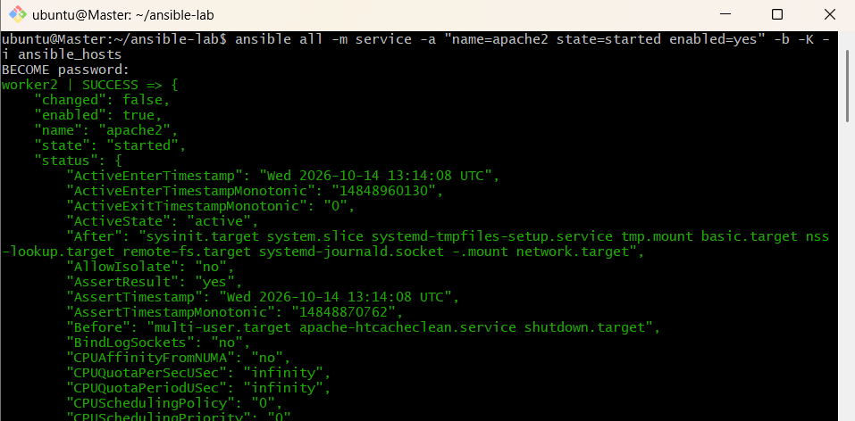
Step 13 — Stop Apache
ansible all -m service -a "name=apache2 state=stopped" -b -K -i ansible_hosts
Expected: Apache stops on both workers.
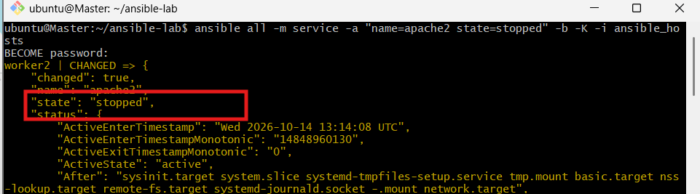
To verify the service state:
ansible all -m command -a "systemctl is-active apache2" -b -i ansible_hosts
Expected output: inactive.
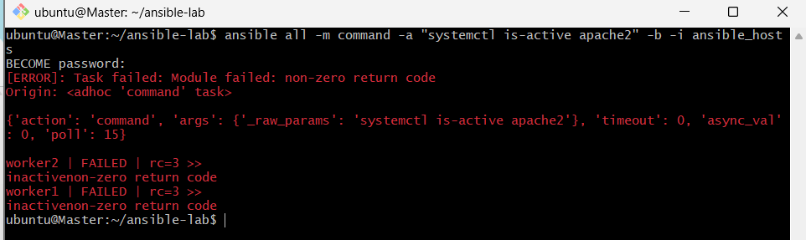
You can restart and enable Apache afterward if you want to leave it running:
ansible all -m service -a "name=apache2 state=started enabled=yes" -b -K -i ansible_hosts
